Shopping Cart System

Project Overview
The Shopping Cart System is a responsive front-end web application built using HTML5, CSS3, Bootstrap 5, and Vanilla JavaScript. The project simulates the core functionality of an e-commerce shopping cart, allowing users to browse products, manage cart items, update quantities, maintain a wish list, and persist data using the browser's Local Storage.
This project was developed as part of my JavaScript learning journey while exploring Object-Oriented Programming (OOP) concepts. It also marks the beginning of my learning experience with Bootstrap, where I focused on creating responsive layouts and modern user interfaces using Bootstrap's grid system, utility classes, cards, buttons, and flexbox utilities.

Objectives
The primary goals of this project were to:
- Apply Object-Oriented Programming principles in JavaScript.
- Build a fully dynamic shopping cart using JavaScript.
- Learn responsive web design using Bootstrap 5.
- Practice DOM manipulation and event handling.
- Implement browser persistence using Local Storage.
- Develop clean, modular, and maintainable code.

Features:

Product Catalog:
- Dynamic product listing
- Product image display
- Product name and pricing
- Responsive Bootstrap cards
- Add to Cart functionality
- Wish list support

Shopping Cart:
Users can:
- Add products to the cart
- Remove products
- Increase quantity
- Decrease quantity
- Automatically remove products when quantity reaches zero
- View individual item subtotal
- View total number of items
- View calculated grand total
- Clear the entire cart

Wish list:
- Add products to a wish list
- Prevent duplicate wish list entries
- Separate wish list management from the shopping cart

Persistent Storage:
The application stores shopping cart data using Local Storage, allowing users to refresh the page without losing their cart contents.

Responsive Design:
The interface is fully responsive and adapts to different screen sizes using Bootstrap's Grid System and responsive utility classes.

Technologies Used:
Technology | Purpose
HTML5 | Application Structure
CSS3 | Custom Styling
Bootstrap 5 | Responsive Layout & UI Components
JavaScript (ES6) | Business Logic
Local Storage API | Data Persistence

Concepts Applied:

JavaScript:
- ES6 Classes
- Constructors
- Objects
- Arrays
- DOM Manipulation
- Event Handling
- Template Literals
- Local Storage API
- Dynamic Rendering
- Object-Oriented Programming

Bootstrap:
This project served as my introduction to Bootstrap. Throughout development, I explored and implemented:
- Responsive Grid System
- Containers
- Rows and Columns
- Bootstrap Cards
- Utility Classes
- Flexbox Utilities
- Responsive Buttons
- Badges
- Rounded Components
- Shadows
- Spacing Utilities
- Typography Utilities

Project Architecture:
The application follows an object-oriented design consisting of two primary classes.

Product Class:
Represents an individual product.

Properties:
- Product ID
- Product Name
- Price
- Image
- Quantity

Shopping Cart Class:
Responsible for managing all shopping cart operations.

Responsibilities:
- Render Products
- Render Cart
- Add Products
- Remove Products
- Increase Quantity
- Decrease Quantity
- Clear Cart
- Wish list Management
- Save Cart
- Load Cart

Application Workflow:
Load Application
│
▼
Display Available Products
│
▼
User Selects Product
│
▼
Add Product to Cart
│
▼
Update Cart UI
│
▼
Calculate Totals
│
▼
Save Cart to Local Storage
│
▼
Refresh Browser
│
▼
Load Saved Cart

Local Storage Implementation:
The project uses the browser's Local Storage API to persist shopping cart data.

Data Stored:
- Shopping Cart Items
- Product Quantities
- Wishlist Items
Data is serialized using:
JSON.stringify()
and restored using:
JSON.parse()
to maintain application state across browser sessions.
Learning Outcomes:
Through this project, I strengthened my understanding of:
- Object-Oriented Programming in JavaScript
- Building reusable classes and objects
- Dynamic DOM manipulation
- Responsive web development using Bootstrap
- Browser storage using Local Storage
- JavaScript array methods such as:
  - find()
  - filter()
  - forEach()
  - map()
- Code organization and modular programming
- UI development using Bootstrap components and utilities

Project Structure:
Shopping-Cart-System/
│
├── index.html
├── style4.css
├── script4.js
│
├──images
│
│
└── README.md

Key Takeaways:
This project represents an important milestone in my web development journey. It allowed me to move beyond basic JavaScript applications by implementing a complete object-oriented architecture while simultaneously learning Bootstrap for responsive interface design. Building this application improved my understanding of component-based thinking, reusable code, state management using Local Storage, and modern front-end development practices.

SCREENSHOTS OF PROJECT:

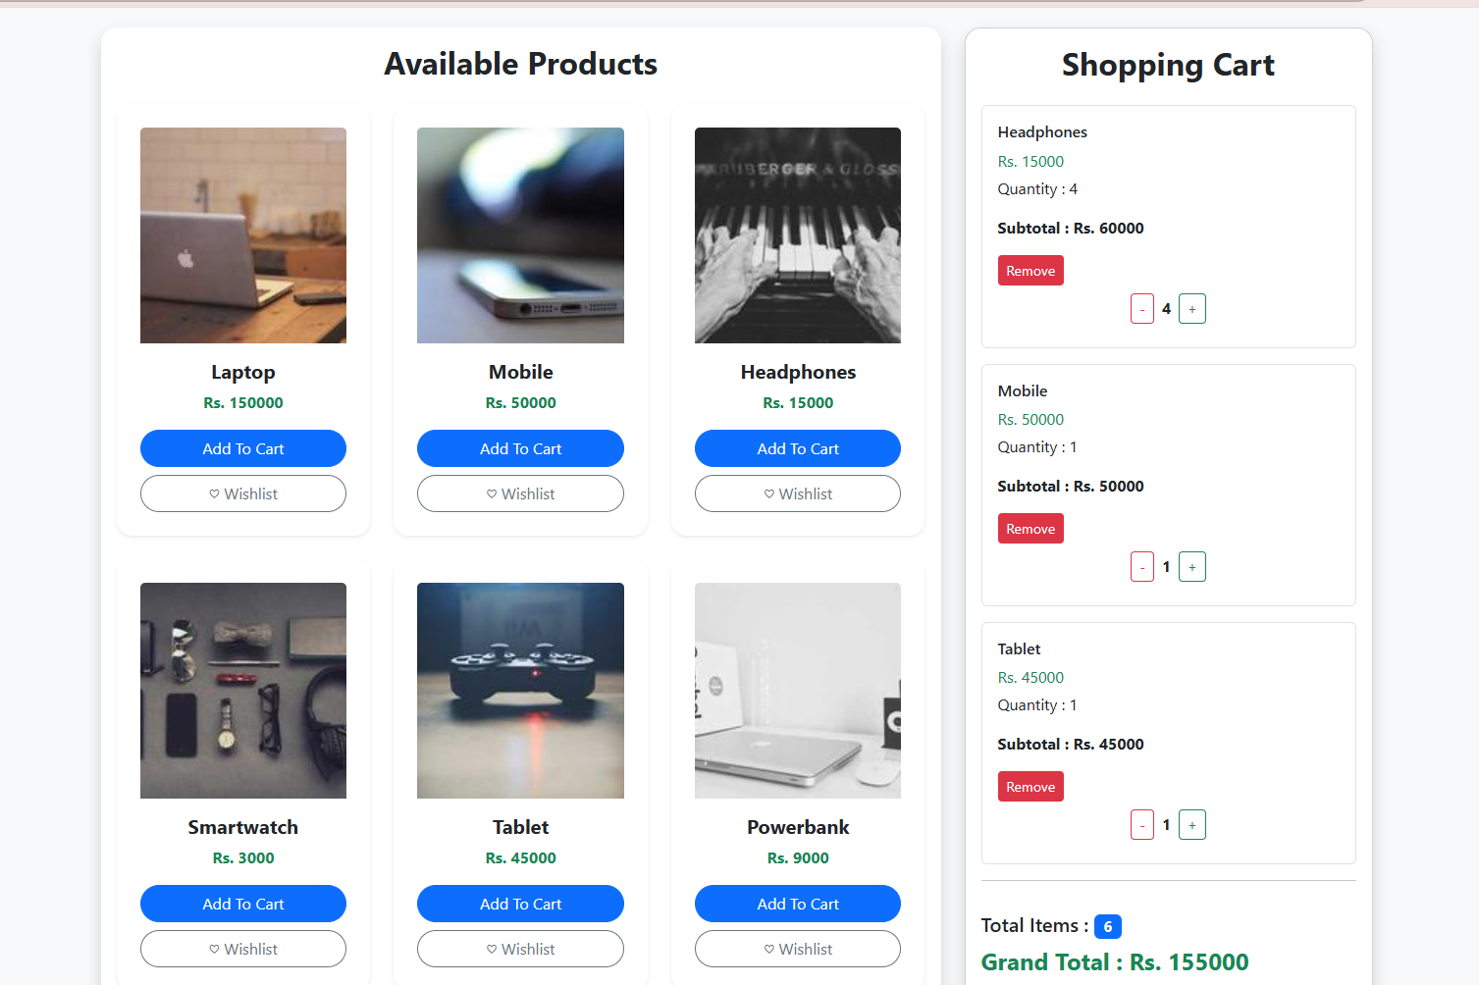

SHOPPING CART: (process)
